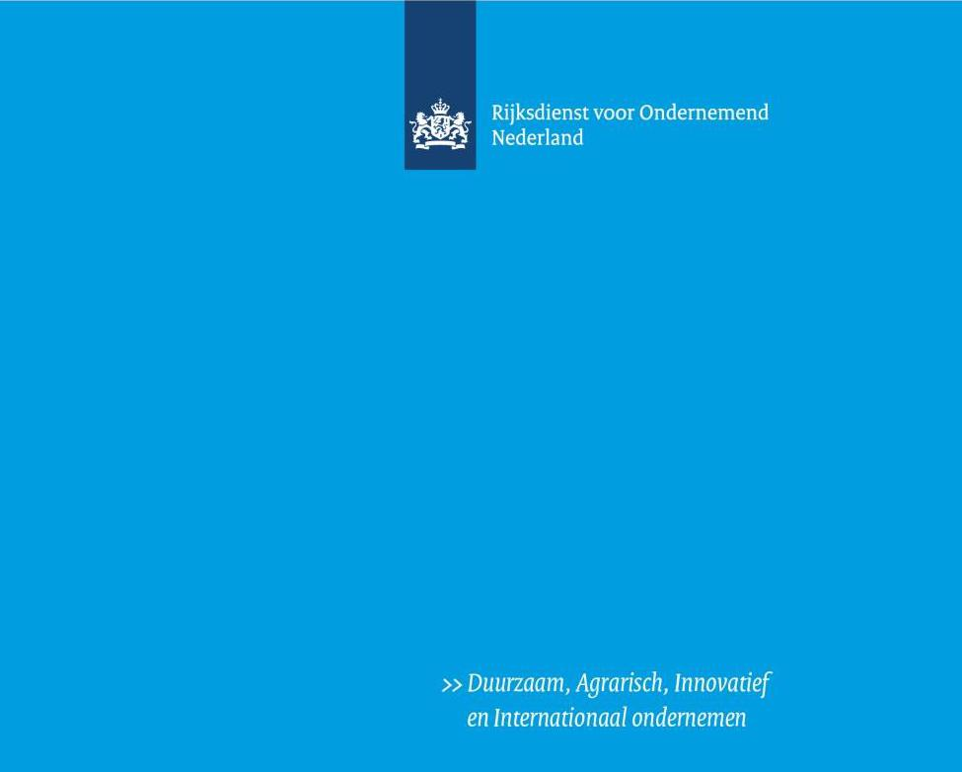

Sector sketch Chemistry

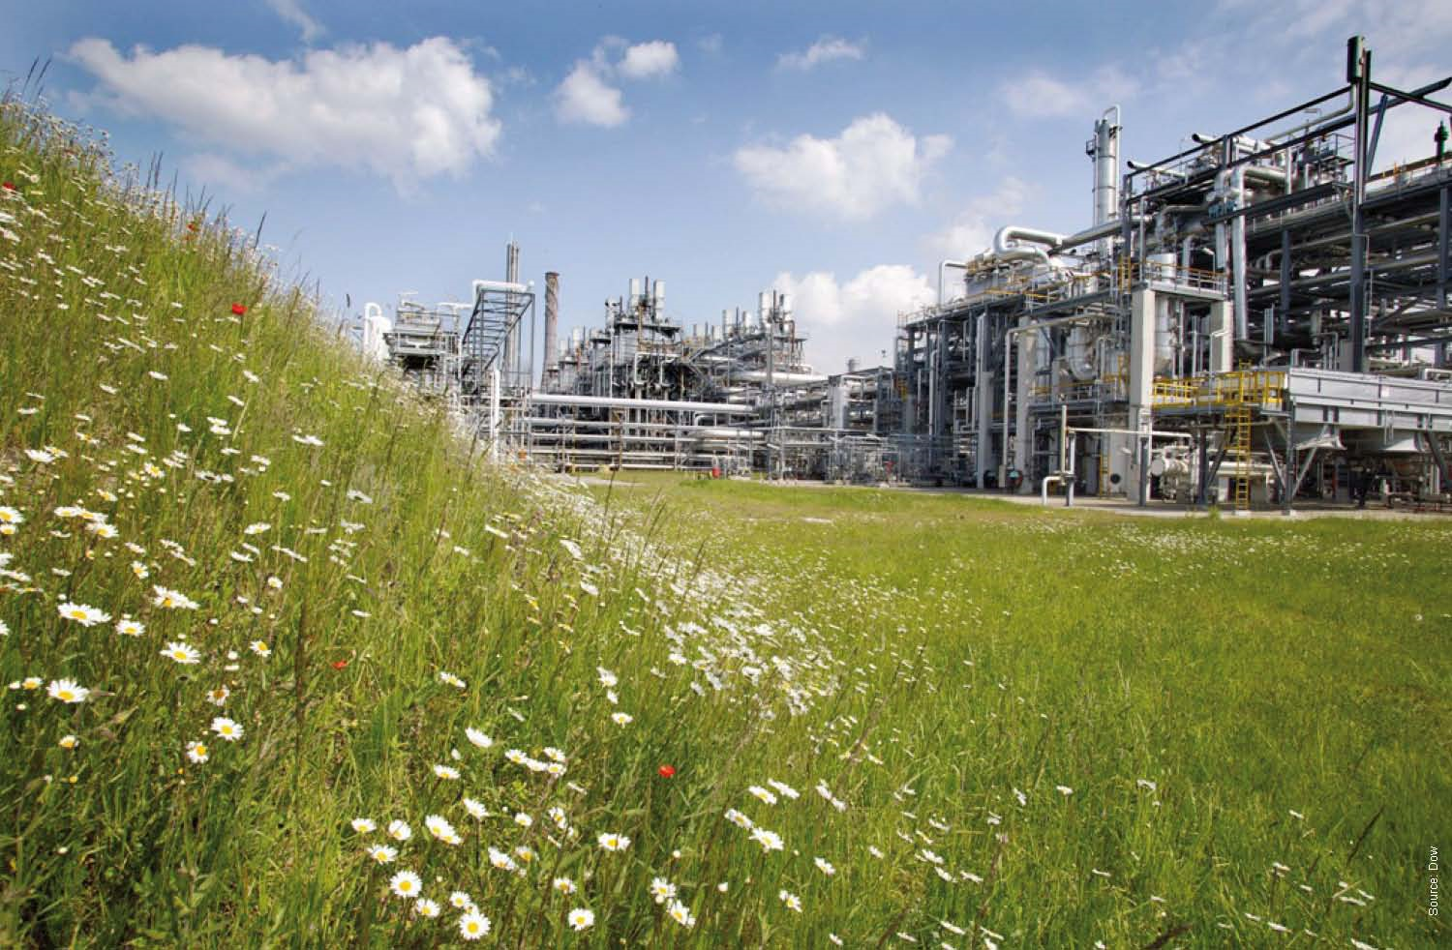

Colofon

Dit is een publicatie van:

Rijksdienst voor Ondernemend Nederland

NBSO Brazil

|  |  |
| --- | --- |
| Opgesteld door: | Marcos Souza (Deputy Representative) |
|  |  |
|  | msouza@nbso-brazil.com.br |
|  |  |
| Contactpersonen: | Marcos Souza |
|  |  |
|  |  |
| Datum: | Juli 2015 |

**© RVO.nl | Mei 2015**

RVO.nl is een agentschap van het ministerie van Economische Zaken. RVO.nl voert beleid uit voor diverse ministeries als het gaat om duurzaamheid, agrarisch, innovatief en internationaal ondernemen. RVO.nl is hét aanspreekpunt voor bedrijven, kennisinstellingen en overheden. Voor informatie en advies, financiering, netwerken en wet- en regelgeving.

RVO.nl streeft naar correcte en actuele informatie in dit dossier, maar kan niet garanderen dat de informatie juist is op het moment waarop zij wordt ontvangen, of dat de informatie na verloop van tijd nog steeds juist is. Daarom kunt u aan de informatie op deze pagina's geen rechten ontlenen. RVO.nl aanvaardt geen aansprakelijkheid voor schade als gevolg van onjuistheden en/of gedateerde informatie. Binnen onze website zijn ook zoveel mogelijk relevante externe links opgenomen. RVO.nl is niet verantwoordelijk voor de inhoud van de sites waar naar wordt verwezen.

**Introduction of the regions where NBSO Brazil operates**

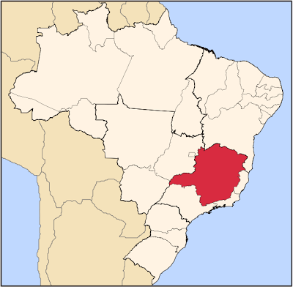

The State of Minas Gerais.

Brazil’s essential exporter (Minerals, Food, Coffee and Dairy) as it is strategically located near the country’s main ports; the state of Minas Gerais holds a good air and road logistics network to flow out the production of major industries.

Minas Gerais has a population of 20 million inhabitants in an area over the size of France. The capital Belo Horizonte has 5,5 million inhabitants in its metropolitan area.

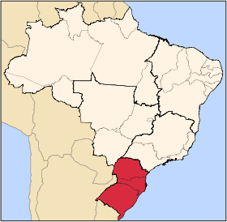The South Region of Brazil.

As one of the most industrialized of the 27 states in Brazil, Rio Grande do Sul, together with the other two southern states of Paraná and Santa Catarina, is strategically located in the centre of Mercosul. Bordering countries as Argentina, Uruguay and Paraguay, with a same distance from major centres in Brazil, e.g. SP, RJ and MG.

Rio Grande do Sul has about 11 million inhabitants. Its capital, Porto Alegre, has 1,5 million inhabitants.

**Major cities**

The State of Minas Gerais: Belo Horizonte, Uberlândia, Contagem, Juiz de Fora.

The South Region of Brazil: Curitiba [capital of Paraná], Londrina, Maringá, Ponta Grossa;

Florianópolis [capital of Santa Catarina], Joinville, Blumenau;

Porto Alegre, Caxias do Sul, Pelotas

**Location NBSO**

Belo Horizonte (MG) and Porto Alegre (RS)

**Delineation and definition of the sector**

The chemical and petrochemical industry is one of the most important sectors of Brazilian economy and, it is among the top ten in the world.

The Petrochemical industry is part of the overall chemical industry, but it is marked by using naphtha or natural gas as raw materials. In the country there are three main petrochemical centers: Camaçari (BA), Triunfo (RS) and the São Paulo´s metro area.

In 2011, Brazil ranked sixth in world’s chemical industries, with a revenue of around US$157 Billion, or 3,1% of the world revenue, estimated at US$5 trillion.

**Chemical Industry: Production and Market**

The chemical industry is the fourth largest manufacturing industry in Brazil, with a share of 2.7% in GDP. The country is a major importer and exporter of chemicals, but the industry is currently witnessing a strong transfer of production abroad.

The domestic production related to the domestic demand is considered not to be in line, which can be explained by the high cost of raw materials, such as natural gas, and low investment in research and development to offer products with a high added value. The government intends to take steps to encourage investment in the sector and increase production.

**Companies and their location**

In numerical terms, the chemical industry has more than four thousand companies large, medium and small, spread over almost all the states of the federation. The state of São Paulo, however, is home to more than half of this total, followed by the states of Bahia, Rio de Janeiro, Rio Grande do Sul and Minas Gerais. All the companies listed in the annex may be considered major players in the chemical industry.

The main highlight in the state of Minas Gerais is the city of Uberaba. There are 43 establishments dedicated to the production of chemicals in the city, and nearly 4000 people employed. There are companies like Bunge, Vale Fertilizantes, Ourofino, and others in the city. In addition, a Petrobras ammonia plant is under construction in Uberaba and it should begin operations in the coming months.

**Sector’s Trade**

*US$36 Billion was the estimation for 2014*

|  |  |  |  |  |
| --- | --- | --- | --- | --- |
| *Export Netherlands to Brazil (x1000€)* | *2011* | *2012* | *2013* | *2014* |
| *5 Chemische producten* | *674821* | *942021* | *827440* | *849441* |
| *51 Organische chemische producten* | *142567* | *128189* | *92024* | *103719* |
| *52 Anorganische chemische producten* | *6125* | *36352* | *x* | *5696* |
| *53 Kleur-, looi- en verfstoffen* | *19720* | *19696* | *x* | *13720* |
| *54 Medicinale en farmaceutische prod...* | *305802* | *454048* | *x* | *481313* |
| *55 Etherische oliën, parfumerieën, ze...* | *14340* | *13823* | *17078* | *14224* |
| *56 Kunstmatige meststoffen* | *75461* | *152511* | *x* | *95794* |
| *57 Kunststof in primaire vormen* | *64614* | *76104* | *x* | *75698* |
| *58 Werken van kunststof n.a.g.* | *7298* | *13625* | *x* | *12903* |
| *59 Andere chemische producten* | *38894* | *47673* | *x* | *46374* |

**Origen of Chemical products in Brazil (2014)**

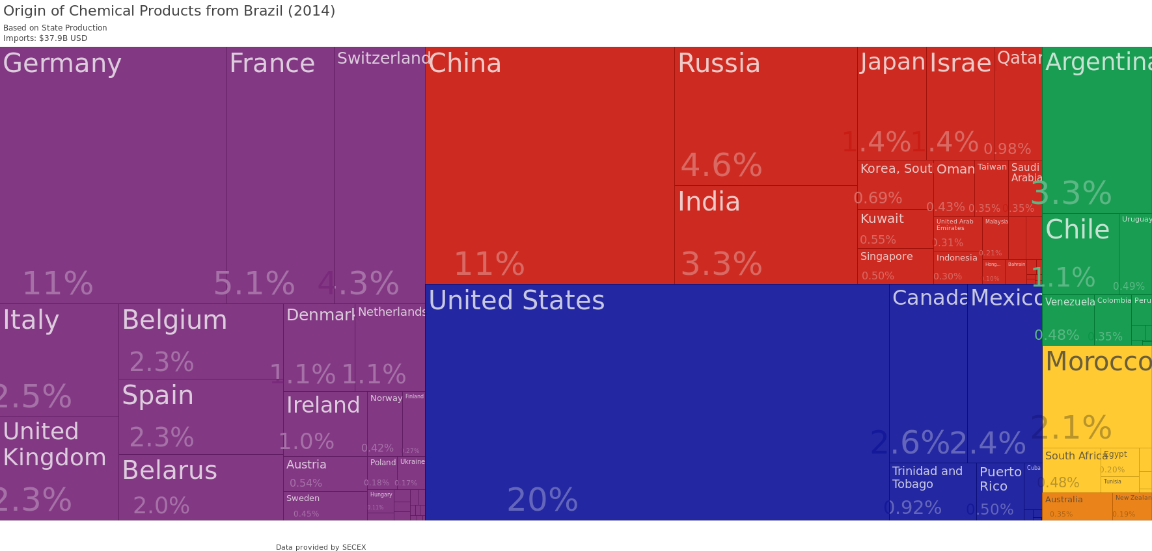

**Business focus: Wholesales or Direct Sales?**

The market works on both wholesales and direct sales as it is widely diversified ranging from raw materials supplied to other industries as agro fertilizers and polymers to cosmetics and pharmaceutical products of which find in Brazilian population an excellent market for direct sales.

**Trends**

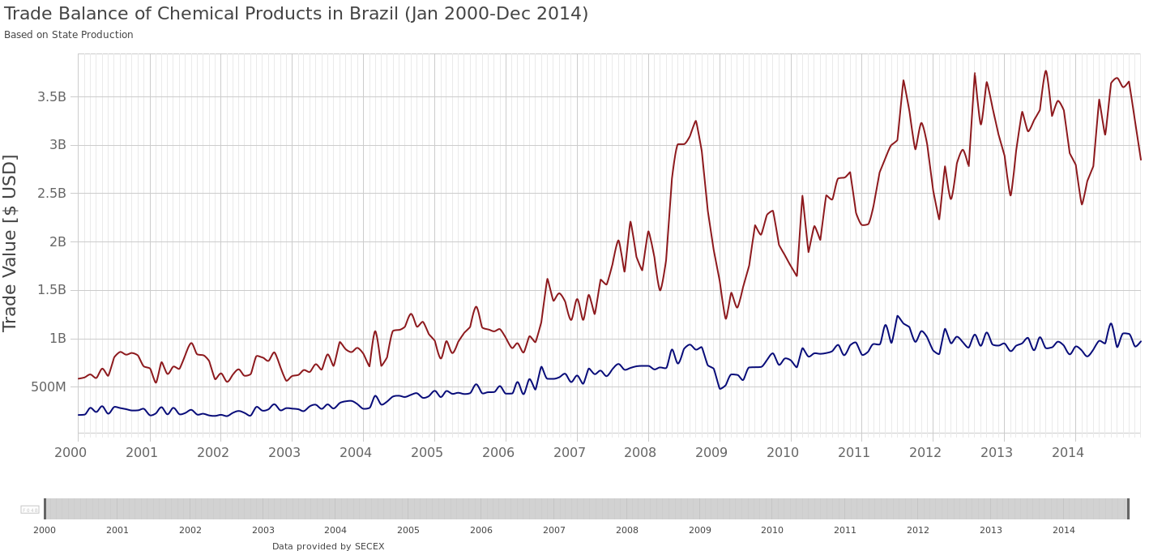

The chemical industry, which production is directed almost entirely at the domestic market, with only residual external sales, has presented very modest growth rates; 0.14% per year on average in the period , due to a lower expansion of Brazil vis-à-vis economic world trade. In fact, the engine of the Brazilian chemical industry growth has been the domestic market, except for periods when the domestic slowdown is compensated by increasing exports, even at the expense of lower prices.

Despite the relatively insignificant growth, it is important to emphasize the distinction between the higher value chemical production, which segments are in the upper-middle of high tech categories, as in the case of pharmaceuticals, and the medium-low standard a low-tech categories, which have achieved great recent growth rates.

The Brazilian chemical production has not been enough to meet the domestic demand on high valued products and thus this demand is increasingly met by imports, which results in growing deficits in the trade balance in times of expansion of the economy. Contributing thereby in a potentially disturbing way to the imbalance in the external accounts, adding to a vulnerability of the Brazilian economy.

The failure of the Brazilian chemical production has been determined by several factors linked to instability in the expansion of domestic demand (for macroeconomic reasons pegged to foreign exchange and interest), the shortage of raw materials which has limited the expansion of investment and plant shift by global reorientation of production of multinational companies, among others. In some cases, the share of domestic production was gradually reduced in absolute terms (decommissioning of plants) or relative (underinvestment to keep up with demand).

**Opportunities**

* The scenario envisioned for the industry in the coming years creates opportunities, especially in the petrochemical, fertilizers (nitrogen) and other organic chemical subsectors, as for example investments in refining is demanded due to the pre-salt oil discoveries, which will create an unimaginable potential for increasing the supply of raw materials.
* There are potential opportunities of international trade in chemicals, especially based on renewable raw materials in the country, as there are competitive advantages of cost and supply, demanding mainly innovation.
* Over the last 10 years, there has been an effort to fulfil all the international regulations and standards regarding safety and environment. Although only about 0.6% of sales revenue is spent on R&D there is a trend towards higher investments. A significant part of R&D is done in the field of Biobased chemicals in compliance with the goal of becoming the greenest country in the world.
* There are opportunities for Dutch consultancy and smart sustainable solutions. Over the last decade, researches were mostly directed at first and second-generation bio energy and biofuels. Currently there is a growing interesting in a wider range of chemicals, although they are probably behind on other major countries.
* Effort is made by governments, incubators and companies to slow the continuously growing trade deficit concerning chemicals. Trade deficit is partial due to the fact that processes that create a higher added value are done abroad. Work is being made to bring those processes to Brazil by tax reliefs and technical cooperation, creating opportunities for Dutch technology and investments.

**Other relevant information**

The chemical industry is a very diversified industry, especially in a large country as Brazil, thus the first attention should be paid to general issues as each segment may have its regulation. It is recommended to take into consideration the location where one wants to do business (each state has specific tariff and incentives for foreign investments); the logistics of special goods in Brazil is also a relevant matter mainly based on regulations for transportation of hazardous cargo.

**Import Regulations**

Despite being one of the largest profitable industries in the world, the Brazilian chemical industry witnesses a strong transfer of production abroad, with the descending of the national industrial production and advancement of imports.

A third of the consumption in the country is already served for products coming from the external market. According to a survey of Abiquim, 448 products are no longer manufactured in Brazil since 1990. This resulted in the stoppage of 1,710 production lines. In 1990, the share of imported products in the Brazilian consumption was only 7%, today it is 30%.

There are standard tariffs for manufactured materials, however it is advisable to check the product’s harmonised code as specific regulations may or not apply. The government often drops importing tariffs of specific goods depending on local demand.

Code Description

II IPI PIS/PASEP COFINS

35% 10% 1.65% 8.6

**Product and Import Requirements**

In Portuguese Tax on Control and Inspection of Chemical Products is named Taxa de Fiscalização de Produtos Químicos.

All chemical products which can be used in the production of narcotic or psychoactive substances or that determine physical or psychological dependence are subjected to control and verification in the production process, storage, commercialization, acquisition, donation, transportation, distribution, importation, exportation, recycling and usage.

Natural and legal entities that perform any of the activities mentioned above have to pay the tax to the Federal Police Department. Public institutions of education, research and health, federal, state and municipal public administration institutions and private assistance, philanthropic and non-profit entities are exempted from the tax.

There are three different costs for the tax on control and verification of chemical products.

* BRL 500.00 for the issue of the registry certificate; the copy of the registry certificate; and alteration on the registry.
* BRL 1000.00 for the issue of an operating license certificate; copy of the operating license certificate and renovation of the operating license
* BRL 50.00 for the issue of a special authorization or copy of the special authorization.

**Other obligations**

The total cost of labour, which includes the analysis of the following items: salaries (including base salary, overtime and additional allowances), other payments (which includes the 13th salary, vacations, the allowance on the holiday, stakes in profits, bonuses, additional service time, notice, plots severance and attendance award), payroll taxes (or compulsory charges, as the company's spending on Social Security, FGTS, education allowance, accident at work, Incra, Sesi, Senai and Sebrae) and benefits (or voluntary charges, as health, recreation, food, transportation, day care assistance and private pension).

The chemical industry manufacturer of products for industrial purposes, like the other industrial sectors in Brazil is subject to numerous laws, decrees and instructions (federal, state and municipal), compulsory standards in the work area, social security, tax and fiscal, environment, product safety and facilities, among others. Due to the federal structure, some aspects are regulated nationally, other by state and still others by the municipalities.

Companies interested in entering the Brazilian market are advised to contact the Dutch Economic Network or NBSO Brazil directly for further information and assistance. NBSO Brazil can help Dutch companies with preparatory information, on for example regulations and can help with finding the right contacts and business partners.

**Sector Fairs and Tradeshows**

The *Analitica Latin America* is one of the main international fairs of chemistry and analytical industry and attracts suppliers, manufacturers and distributors of laboratory technology sectors, quality control and biotechnology seeking references and news for their production and closing deals.

The *Food Ingredients South America* is the main and largest event for food ingredients in Latin America and it has become a unique opportunity for companies working in the segment of ingredients, services and technologies for food and beverage industry in general.

*ABRAFATI* is the most important fair in the paint industry throughout Latin America encouraging the development of the segment of paints and varnishes in Brazil. It aims to bring references and discussions on raw materials, processes, products, applications, technologies, environmental impacts and many matters of great importance for professionals and entrepreneurs of the entire production chain of paint and varnish draw their professional and production guidelines

*The International Fair for Suppliers of Chemical and Petrochemical Industry* is considered a meeting point for the entire chain of the segment with all its suppliers aiming to generate business, propose new solutions and promote the chemical sector market.

**Main associations**

The Southeastern region of the country is considered the industrial hub, especially the states of São Paulo and Rio de Janeiro. Not differently would be for the sector’s associations that are easily found in the city of São Paulo and surroundings, only ABIQUIFI has its main office in the city of Rio de Janeiro.

* **Brazilian Chemical Industry Association – ABIQUIM** - Inorganics, Organics Resins and Elastomers, Miscellaneous Chemicals [[www.abiquim.org.br]](http://www.abiquim.org.br)
* **Brazilian Association for Artificial and Synthetic Fibres’ manufacturers – ABRAFAS** - Fibres, Wires, Cables and Artificial and Synthetic Continuous Filaments [www.abrafas.org.br]
* **Industry of Pharmaceutical Products’ Union – SINDUSFARMA** [<http://sindusfarma.org.br>]
* **Brazilian Association for Pharma Chemical Industry and Pharmaceutical materials – ABIQUIFI** – Pharmaceutical [<http://abiquifi.org.br>]
* **Agricultural aviation companies’ national Union – SINDAG** – Pesticides [www.sindag.org.br]
* **Association of Industries of Personal Hygiene, Perfumes and Cosmetics – ABIHPEC** [www.abihpec.org.br]
* **Brazilian Association of Cleaning products’ Industries – ABIPLA** - soaps, detergents, cleaning products and personal care items [www.abipla.org.br]
* **Brazilian Coatings Manufacturers Association – ABRAFATI** - Coatings, Varnishes, Lacquers and Enamels, Related products [www.abrafati.com.br/en/about-us]

**Sources**

*Minas Gerais governmental statistical database*

<http://en.dataviva.info/profiles/hs/06/?app=8>

*PWC: Indústria Química no Brasil, um panorama*

<http://www.pwc.com.br/pt_BR/br/publicacoes/setores-atividade/assets/quimico-petroquimico/chemicals-port-13e.pdf>

*ABRAFATI: Competitividade da Indústria*

<http://www.abrafati.com.br/wp-content/uploads/2013/06/competitividade-da-industria.pdf>

*ABIQUIM: A Indústria Química*

[www.abiquim.org.br/pdf/indQuimica/AIndustriaQuimica-SobreSetor.pdf](http://www.abiquim.org.br/pdf/indQuimica/AIndustriaQuimica-SobreSetor.pdf)

*The Brazilian Chemical Industry: Road to Sustainability*

<http://arquivos.portaldaindustria.com.br/app/conteudo_18/2013/09/23/4970/20131003112324944144i.pdf>

*Journal of the Brazilian Chemical Society*

*J. Braz. Chem. Soc. vol.23 no.11 São Paulo Nov. 2012*

<http://www.scielo.br/scielo.php?script=sci_arttext&pid=S0103-50532012001100001>

**Annex 1 – list of mayor chemical companies in Brazil**

**3M**

Founded in the United States in 1902, and established in Brazil since 1946, the company has over 35 business units filtered into 6 groups: Consume and Office, display and Graphical communication, Health care, Safety and Cleaning.

It is responsible for 50 well-known brands as Scotch-BriteMR, Post-it®, Scotch®, NexcareMR, Scotchgard™, PonjitaMR, Durex®, Command™ e NomadMR, market top-leading brands.

**Location:** SÃO PAULO

**Segment:** Chemical and Petrochemical

**Management:** American

**Net Sales(R$ Million):** Value: 1,927,6

**Net Profit (US$ Million):** Adjusted: 108,3

**Net Worth (US$ Million):** Adjusted: 402,3

**Number of employees:** About3790

**Active in stock market:** No

**BASF**

Founded in 1865, it has opened its first commercial representation in 1911 in the city of Rio de Janeiro. Having a portfolio of about 8,000 products, it ranges from plastics, polyurethanes, industrial chemicals, performance products and paints, agricultural and fine chemicals, to crude oil and natural gas. Among its brands are famous Suvinil.

**Location:** SÃO PAULO

**Segment:** Chemical and Petrochemical

**Management:** German

**Net Sales(R$ Million):** Value: 5755,1

**Net Profit (US$ Million):** Adjusted: 139,7

**Net Worth (US$ Million):** Adjusted: 924,7

**Number of employees:** About3940

**Active in stock market:** No

**BUNGE**

Founded in 1818 under the name Bunge & Co. in Amsterdam, its activities in Brazil began in 1905, when it has participated in the capital of SA Santista Mill General Industries, purchase and wheat milling company from Santos (São Paulo - Brazil).

However, the fertilizer commercialization activities are initiated only in 1938, with the incorporation of Serrana SA de Mineração. In this sector, brands are Serrana, Manah and Iap

**Location:** SÃO PAULO

**Segment:** Chemical and Petrochemical

**Management:** Dutch

**Net Sales(R$ Million):** Value: 4473,6

**Net Profit (US$ Million):** Adjusted: 131,7

**Net Worth (US$ Million):** Adjusted: 755,7

**Number of employees:** About1750

**Active in stock market:** No

**HERINGER**

Founded in 1968 in Minas Gerais and later moving to Vitória, Espírito Santo. Among its products, there are basic fertilizers, NPK and Special fertilizers supplied to 23 different states plus the federal capital.

**Location:** ESPÍRITO SANTO

**Segment:** Chemical and Petrochemical

**Management:** Brazilian

**Net Sales(R$ Million):** 4833,6

**Net Profit (US$ Million):** Adjusted: 35,9

**Net Worth** **(US$ Million):** Adjusted: 268,4

**Number of employees:** About 3420

**Active in stock market:** Yes

**BRASKEM**

In 2002, Braskem starts business, controlled by the group Odebrecht. It produces high-density polyethylene, low density, linear low density, ultra-high molecular weight (UTEC®), green polyethylene, ethanol from sugarcane, polypropylene homopolymers, random copolymers and heterophasic copolymers, aside from special families Prisma® and Symbios. PVC, ethylene, propylene, butadiene, benzene, xylenes, toluene and gasoline, automotive bioadditive ETBE, soda and derivatives.

**Location:** BAHIA

**Segment:** Chemical and Petrochemical

**Management:** Brazilian

**Net Sales(R$ Million)**: Value: 18706,6

**Net Profit** **(US$ Million)**: Adjusted: 381,9

**Net Worth** **(US$ Million)**: Adjusted: 5558,5

**Number of employees**: About 4990

**Active in stock market:** Yes

**ANGLOAMERICAN - COPEBRAS**

In 1955 it was created Copebrás (Brazilian Petrochemical Company), focused on the production of carbon black. The production of phosphate fertilizers began in 1966 and later becomes the most renowned product of the company. The Anglo American Group bought Copebrás in 1985 and the production of phosphate rock has been expanded.

**Location:** SÃO PAULO

**Management:** English

**Net Sales(R$ Million)**: Value: 979

**Net Profit** **(US$ Million)**: Adjusted: 63,1

**Net Worth (US$ Million)**: Adjusted: 213,9

**Number of employees:** About 1250

**Active in stock market:** No

**DUPONT**

DuPont has more than 200 years and is present in Brazil since 1937. It operates in the agricultural segment, chemical, petrochemical, automotive, graphic and in the areas of packaging, industrial polymers, electronics, construction, decoration, security, paper, pulp, household products and biotechnology.

**Location:** SÃO PAULO

**Segment:** Chemical and Petrochemical

**Management:** American

**Net Sales(R$ Million):** Value: 3436,1

**Net Profit (US$ Million):** Adjusted: 157,3

**Net Worth (US$ Million):** Adjusted: 990,7

**Number of employees:** About 6330

**Active in stock market:** No

**REFAP**

The refinery began operations in 1968 in Rio Grande do Sul. In 2001, became a public company and it was named Alberto Pasqualini -. REFAP SA. Part of the Petrobras Group.

**Location:** RIO GRANDE DO SUL

**Segment:** Chemical and Petrochemical

**Management:** Brazilian

**Net Sales(R$ Million):** Value: 6905,4

**Net Profit (US$ Million):** Adjusted: 295,8

**Net Worth (US$ Million):** Adjusted: 716,5

**Number of employees:** About 920

**Active in stock market:** No

**OXITENO NE**

Founded in 1973 in São Paulo’s metro area, the plant Oxiteno was the first chemical company in Latin America to produce Ethylene Oxide and derivatives.

It has a portfolio of products such as oxygenated solvents, special solvents, green solvents, surfactants, ionic surfactants, anionic surfactants special surfactants, coalescing, consistency agents, emulsifiers, pearlizing agents, wetting and solubilizing.

**Location:** BAHIA

**Management:** Brazilian

**Net Sales(R$ Million):** Value: 1368,4

**Net Profit (US$ Million):** Adjusted: 25

**Net Worth (US$ Million):** Adjusted: 450,7

**Number of employees:** About290

**Active in stock market:** No

**CLARIANT**

Founded in 1995 as an independent company, it began operations in Brazil in 1997. It has a portfolio of products such as additives, catalysts, emulsions, detergents and intermediates, functional materials, chemicals and services for the leather market, master batches, products and services for the oil, refinery and mining, specialty chemicals for pre-treatment, colorant, printing and finishing fabrics, organic pigments, pigment preparations, and solutions for bleaching, colour, finish and strength to the paper market.

**Location:** SÃO PAULO

**Management:** Swiss

**Net Sales(R$ Million):** Value: 1105,6

**Net Profit (US$ Million): Adjusted:** 31,8

**Net Worth (US$ Million):** Adjusted: 143

**Number of employees:** Not provided

**Active in stock market:** No

**INNOVA S/A**

Established in 1996, produces polystyrene, ABS and SAN, styrene, ethylbenzene, toluene among other services.

**Location:** RIO GRANDE DO SUL

**Management:** Argentinian

**Net Sales(R$ Million):** Value: 1059,8

**Net Profit (US$ Million):** Adjusted: 25,7

**Net Worth (US$ Million):** Adjusted: 206,4

**Number of employees:** Not provided

**Active in stock market:** No

**WHITE MARTINS**

Founded in 1912, in Rio de Janeiro, as MacLauchlan e Cia., a year later it has changed its name to White Martins. It produces services and equipments to environmental demands, management on the client´s plant, welding and cutting tasks, it owns an industrial gas portfolio.

**Location:** RIO DE JANEIRO

**Management:** American

**Net Sales(R$ Million):** Value: 2492,6

**Net Profit (US$ Million):** Adjusted: 195,7

**Net Worth (US$ Million):** Adjusted: 1414

**Number of employees:** About 3470

**Active in stock market:** No

**QUATTOR**

Quattor emerges in 2008, with the shareholders Unipar and Petrobras and gathering the Petrochemical Union, Unipar Chemical Division, Union Polyethylene, Polymers River and Suzano. Founded in Rio de Janeiro, it was the second largest petrochemical company in the country, second only to Braskem, which bought it in 2010.

**Location:** SÃO PAULO

**Management:** Brazilian

**Net Sales(R$ Million):** Value: 1987,8

**Net Profit (US$ Million):** Adjusted: 27,3

**Net Worth (US$ Million):** Adjusted: 508,7

**Number of employees:** Not provided

**Active in stock market:** Yes

**RIO POLÍMEROS**

Opened in June 2005, it is the first gas-chemical enterprise in Brazil and the second largest polyethylene producer in the country. Rio Polímerosnew petrochemical complex in Duque de Caxias is said to be Latin America's largest integrated gas-based chemical site. Inaugurated during the second half of 2005, the complex is able to produce 520,000tpa of ethylene, which is used as feedstock for a polyethylene unit with a capacity of 540,000tpa. 75,000tpa of propylene is also made at the site. Brazilian polypropylene producer Polibrasil will use the propylene.

Riopol is a joint venture between Cia Suzano de Palele Celulose (33.3%), União de Industrias Petroquimicas (33.3%), Petrobras Química (16.7%) and BNDES (16.7%).

**Location:** RIO DE JANEIRO

**Management:** Brazilian

**Net Sales(R$ Million):** Value: 1550,2

**Net Profit (US$ Million):** Adjusted: 39,0

**Net Worth (US$ Million):** Adjusted: 996,2

**Number of employees:** About 380

**Active in stock market:** No

Netherlands Business Support Office Brazil

Rua Sergipe 1167, Ed. Sibelius, sala 1502

30130-171 Savassi, Belo Horizonte - MG

Tel.: +55 (0)31 3504 3381

Av. Carlos Gomes, 222, Business Center, sala 802

90480-000 - Porto Alegre - RS

Tel.: +55 (0) 51 33781144

Email: info@nbso-brazil.com.br

Twitter: @NBSOBrazil

www.nbso-brazil.com.br